ONLINE RETAIL SALES ANALYSIS
Using Python

PROJECT REPORT

Prepared By
Atoofa Anwar
Tools Used

Pythons
Pandas
NumPy
Matplotlib

Dataset
Online Retail Dataset
Date
2 July 2026

TABLE OF CONTENTS

Introduction
The Online Retail Sales Analysis project was conducted to analyze the sales performance, customer purchasing behavior, product performance, and country-wise revenue distribution using the Online Retail dataset.
The objective of this project is to identify business trends, understand customer buying patterns, evaluate product performance, and generate useful business insights that can help improve decision-making.
Python and its data analysis libraries were used to clean the data, perform exploratory data analysis (EDA), visualize trends, and conduct RFM analysis for customer segmentation.
The findings of this project can help businesses improve customer retention, optimize inventory, identify high-performing products, and develop better marketing strategies.

Business Problem
The company collects a large amount of sales data from online transactions. However, without proper analysis, it is difficult to understand sales trends, customer purchasing behavior, product performance, and revenue distribution across different countries.
The business needs to identify its most valuable customers, best-selling products, and high-revenue markets in order to improve business performance and make data-driven decisions.
This project aims to solve these business problems by analyzing the Online Retail dataset and providing meaningful insights that support better marketing strategies, customer retention, inventory planning, and overall business growth.

Project Objectives
The main objectives of this project are:
- To analyze the overall sales performance of the online retail business.
- To understand customer purchasing behavior.
- To identify high-performing products based on sales and revenue.
- To analyze country-wise revenue contribution.
- To perform RFM Analysis for customer segmentation.
- To generate meaningful business insights and recommendations for better decision-making.

Dataset Description
The dataset used in this project is the Online Retail Dataset, which contains transactional data of an online retail company.
The dataset includes customer purchase information such as invoice details, product descriptions, quantity purchased, invoice date, unit price, customer ID, and country.
This dataset is widely used for data analysis and customer segmentation projects because it provides real-world business transaction data.
The dataset was used to perform data cleaning, exploratory data analysis (EDA), sales analysis, customer analysis, product analysis, country-wise revenue analysis, and RFM analysis.

Column Name | Description
InvoiceNo | Unique Invoice Number for each transaction
StockCode | Unique Product Code
Description | Product Name/Description
Quantity | Number of products purchased
InvoiceDate | Date and Time of Purchase
UnitPrice | Price of one product
CustomerID | Unique Customer Identifier
Country | Country of the Customer

Data Cleaning
Before performing data analysis, the dataset was cleaned to improve data quality and ensure accurate results.
The following data cleaning steps were performed:
- Checked for missing values and handled them appropriately.
- Removed duplicate records to avoid repeated transactions.
- Removed cancelled orders identified by the letter "C" in the Invoice Number.
- Removed records with negative quantity values.
- Converted the InvoiceDate column into datetime format for date-based analysis.
- Created a new Sales column by multiplying Quantity and UnitPrice.
- Verified the cleaned dataset before performing Exploratory Data Analysis (EDA).

Exploratory Data Analysis (EDA)
After completing the data cleaning process, Exploratory Data Analysis (EDA) was performed to understand the overall business performance and identify meaningful patterns in the dataset.
The analysis focused on sales trends, customer purchasing behavior, product performance, and country-wise revenue distribution. Different charts and summary statistics were used to visualize the data and extract business insights.
The EDA results helped identify key business opportunities, customer segments, and revenue-generating markets, which were later used to provide business recommendations.

Monthly Sales Analysis
Objective
To analyze the monthly sales trend and identify seasonal business patterns.
Observation
- Monthly revenue remained relatively stable during the first half of the year.
- Sales increased significantly during September, October, and November.
- November recorded the highest monthly revenue.
- A decline in revenue was observed in December because the dataset contains data only until 9 December 2011.
Business Insight
The business experiences strong sales during the festive season. The company should maintain sufficient inventory and prepare marketing campaigns before September to maximize revenue.

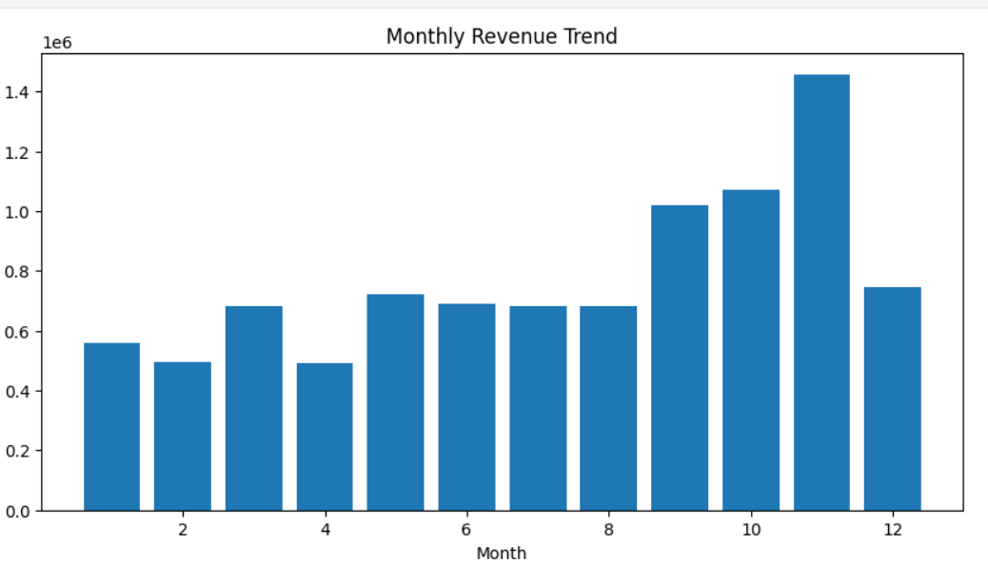
Business Insights
- Sales peaked during the festive season.
- The United Kingdom is the primary revenue-generating market.
- A few products contribute most of the revenue.
- Repeat customers are highly valuable for business growth.
- RFM analysis identified different customer segments that require different marketing strategies.
Business Recommendations
- Reward Champion customers with loyalty programs.
- Re-engage At Risk customers using personalized offers.
- Increase inventory before the festive season.
- Maintain sufficient stock of high-performing products.
- Expand business in high-potential international markets.
- Continue using customer segmentation for targeted marketing campaigns.
- Conclusion
- This project successfully analyzed the Online Retail dataset using Python. The analysis provided valuable insights into sales performance, customer purchasing behavior, product performance, country-wise revenue, and customer segmentation using RFM analysis.
- The findings can help businesses improve customer retention, optimize inventory management, strengthen marketing strategies, and support data-driven decision-making for future growth.

